hi

Final Examination (Solution)
(Fall, 1999-2000)
ENGG 201 - Behaviour of Liquids, Gases and Solids
December 14, 1999 Time Allowed: 180 minutes.

- Attempt all six (6) questions. Weighting as noted. Total marks = 100.
- The textbook and electronic calculators are permitted. Notes are not allowed.
- Print your name clearly in the space provided on the cover page. Write your ID No. on the last page and all other pages in the provided space.

Surname: ____________________ Given Name(s):______________________ Section* ______

*L01 for MWF Lectures; L02 for T R Lectures.

STUDENT IDENTIFICATION
Each candidate must sign the Seating List confirming presence at the examination. All candidates for final examinations are required to place their University of Calgary student l.D. cards on their desks for the duration of the examination. (Students writing mid-term tests can also be asked to provide identity proof.) Students without an l.D. card who can produce an acceptable alternative l.D. e.g. one with a printed name and photograph, are allowed to write the examination.
A student without acceptable l.D. will be required to complete an Identification Form. The form indicates that there is no guarantee that the examination paper will be graded if any discrepancies in identification are discovered after verification with the student's file. A Student who refuses to produce identification or who refuses to complete and sign the Identification Form is not permitted to write the examination.

EXAMINATION RULES
(1) Students late in arriving will not normally be admitted after one-half hour of the examination time has passed.
(2) No candidate will be permitted to leave the examination room until one-half hour has elapsed after the opening of the examination, nor during the last 15 minutes of the examination. All candidates remaining during the last 15 minutes of the examination period must remain at their desks until their papers have been collected by an invigilator.
Question  No. | Maximum  Marks | Mark  Obtained
1 | 18
2 | 17
3 | 16
4 | 18
5 | 16
6 | 15
Total (out of 100)

(3) All inquiries and requests must be addressed to supervisors only.
(4) Candidates are strictly cautioned against:
(a) speaking to other candidates or communicating with them under any circumstances whatsoever: (b) bringing into the examination room any textbook, notebook or memoranda not authorized by the examiner;
(c) making use of calculators and/or portable computing machines not authorized by the instructor: (d) leaving answer papers exposed to view;
(e) attempting to read other student's examination papers.

The penalty for violation of these rules is suspension or expulsion or such other penalty as may be determined.
(5) Candidates are requested to write on both sides of the page, unless the examiner has asked that the left hand page be reserved for rough drafts or calculations.
(6) Discarded matter is to be struck out and not removed by mutilation of the examination answer book.
(7) Candidates are cautioned against writing in their answer book any matter extraneous to the actual answering of the question set.
(8) The candidate is to write his/her name on each answer book as directed and is to number each book.
(9) A candidate must report to a supervisor before leaving the examination room.
(10) Answer books must be handed to the supervisor-in-charge promptly when the signal is given. Failure to comply with this regulation will be cause for rejection of an answer paper.
Question #1. (18 points)
The phase behaviour of Propane-Ethylene mixtures at 800 kPa is shown in the T-X diagram below. The critical properties of Propane (C₃H₈; M = 44 kg/kmol) and Ethylene (C₂H₄; M = 28 kg/kmol) are listed in Table B-2, page 388 of the textbook. A storage tank contains 1000 kg of a mixture of Propane and Ethylene containing 50 mole percent propane at a temperature of 260 K.
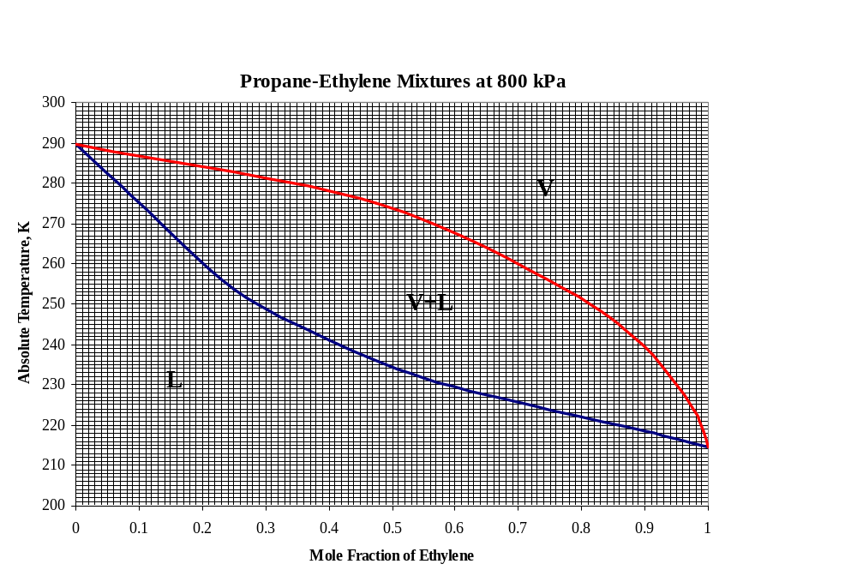

(a) What is the average molar mass of the mixture? (1 pt)
Molar mass of the mixture = 0.5 * 44 + 0.5 * 28 = 36 kg/kmol

(b) What is the total number of kmols of material present in the tank? (1 pt)
Total number of kmol in the mixture = 1000 kg/(36 kg/kmol) = 27.78 kmol

(c) What is the bubble point temperature of the mixture? (1 pt)
234 K

(d) What is the composition of the vapour phase at T=260K? (1 pt)
70 mole% Ethylene, 30 mol% Propane

(e) How many kmols of material are in the vapour phase? (2 pts)
By lever rule, the fraction of total number of moles in the vapour phase is
(0.5 - 0.2)/(0.7 - 0.2) = 0.6
Kmol in the vapour phase = 27.78 * 0.6 = 16.67 kmol

(f) What is the mass of the vapour phase? (2 pts)
Molar mass of the vapour phase = 0.7 * 28 + 0.3 * 44 = 32.8 kg/kmol
Mass of the vapour phase = 16.67 kmol * 32.8 kg/kmol = 546.8 kg.

(g) The mixture is heated to temperature T=300K such that it is all vapour and has the same initial molar composition, i.e. 50 mol% Propane and 50 mol% Ethylene. Estimate the molar volume of the mixture at 300K and 800 kPa, using the compressibility chart and the pseudo-critical point method. (10 pts)
The critical properties are:
T_{c}: Ethylene 282.4 K; Propane 369.8 K Pc: Ethylene 49.7 atm; Propane 41.9 atm
T_{pc} = 0.5 * 369.8 + 0.5 * 282.4 = 326.1 K P_{pc} = 0.5 * 41.9 + 0.5 * 49.7 = 45.8 atm
T_{r} = 300/326.1 = 0.92 P_{r} = 800/(45.8 * 101.3) = 0.172
From the chart on page 395, Z = 0.92

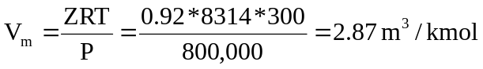

Question # 2: (17 points)
The normal boiling point of Benzene (C₆H₆, M=78kg/kmol) is T_{b}=80.1ºC, and its vapour pressure is 53.33 kPa at T=60.6 ºC.
N.B. Use units of kPa for the pressure throughout this problem.

- Use the above information to determine the average latent heat of vaporization (ΔH_{v}) and the constant C_{o} in the Clapeyron equation (vapour pressure correlation). (5 pts)
P_{V1}=1atm=101.325 kPa → T₁=T_{b}=80.1ºC=353.25K
P_{V2}=53.33 kPa → T₂=60.6ºC=333.75K
ln(P_{V1}) = -ΔHv/RT₁ + C
ln(P_{V2}) = -ΔHv/RT₂ + C
Solving for ΔHv and Co gives: ➔ ΔHv=32.263*10³ kJ/kmol
➔ Co =15.60

- Determine the boiling temperature of Benzene at a pressure P=62kPa. (2 pts)
ln(P_{V}) = -ΔHv/RT + C = -32.263*10³/(8.314*T) + C = -3880.54/T + 15.60

If P_{V} =62 kPa, then we get: ➔ T_{B} = 338.24K=65.09ºC

- 10 kg of Benzene is heated through the following three stages under a constant pressure P = 62 kPa (isobaric conditions). First, Benzene is heated from its initial temperature T_{i} = 60 ºC till it reaches its boiling temperature. Then, it is vaporized completely. In the third stage, the vapour is heated to a final temperature T_{f} = 70 ºC.
Determine the amount of energy (in units of kJ) required for the whole process. For the heat capacities, use the values listed in the book on page 215. (5 pts)

Benzene: M=78kg/kmol → ΔHv= 32.263*10³/78 = 413.63 kJ/kg
ΔE = m[C_{PL} (T_{B} -T_{i}) + ΔHv + C_{Pv} (T_{f}- T_{B})]
=10*[2.02*(65.09-60) +413.59 +1.21*(70-65.09)]
➔ ΔE =4298.6 kJ

(d) The vapour pressure of Toluene at the normal boiling point of Benzene T=80.1 ºC, is equal to
46.66 kPa. Use Raoult’s law to determine the molar composition of a liquid solution of Toluene and Benzene that would boil at T=80.1 ºC under a pressure of 67 kPa. (5 pts)

P = x₁ P_{V1} + x₂ P_{V2} = x₁ P_{V1} +(1 - x₁) P_{V2} = x₁ (P_{V1} - P_{V2}) P_{V2}
→ x₁= (P - P_{V2})/(P_{V1} - P_{V2})

At the normal boiling point of Benzene, the vapour pressure P_{V1}= 1atm =101.325 kPa
➔ x₁=(67 –46.66)/(101.325-46.66)
= 0.37
➔ x₂= 1- x₁ =0.63

Question #3: (16 points)
A pipeline is used to carry oil over long distances. Pumping stations are provided whenever the pressure in the pipeline falls to 30 kPa. The first pumping station at the starting point delivers a pressure of 430 kPa.
We assume that the pipeline is smooth and that it rises in elevation at a constant rate of 4 m every 1 km of pipe length. Furthermore, we give the following data:
Oil density, ρ = 800 kg/m³
Oil viscosity μ = 0.082 Pa.s
Pipe diameter, D = 1.2 m
Oil flow rate Q = 3*10⁵ barrels/day

1 barrel = 44 gallons = 0.167 m³

- Determine the average velocity in the pipeline. (2 pts)

Q = 3*10⁵ *0.167/(24*3600) = 0.580 m³/s
Q = π D²ū/4 ➔ ū = 4 Q/πD²
= 4*0.580/(3.14*(1.2)²)
=0.513 m/s

- Find the Reynolds number in the pipe. Is the flow laminar or turbulent? (2 pts)

➔ Re = ρ ū D/μ
= 800*0.513*1.2/0.082
=6006
➔ Re > 4000: Turbulent flow.

- Determine the angle of inclination of the pipe, θ. (2 pts)

➔sin(θ) = h/L = 4/10³ = 4*10⁻³
θ ≈ sin(θ) =0.004 rad = 0.229º

- Estimate the distance along the pipeline between the first and the second pumping stations. (10 pts)

-ΔP –ρgh = -ΔP –ρgLsin(θ) =2ρfL ū²/D
→ -ΔP = (2ρf ū²/D + ρgsin(θ))L
→ L = -ΔP/(2ρf ū²/D + ρgsin(θ))
But: -ΔP = P₂ –P₁ = 30 –430 = -400 kPa
Re=6006 → (Moody Chart) f≈ 0.009
➔ L = 11.577 km

Question # 4: (18 points)
A cylindrical pipe with a 5 cm inner diameter is used to carry a hot fluid. The pipe's wall is 5 mm thick and has a thermal conductivity of 25 W/(m.K).

- Determine the rate of heat loss per unit length (in units of kW/m) if the temperature of the hot fluid is 300 ºC, and the outer surface of the cylinder remains at the ambient temperature of 25 ºC. (6 pts)

Ro = 2.5cm
R1 = 2.5 +0.5=3cm
→ (Q/L) = -2 π *(T1-To) *Κo/ln(R1/Ro) =
-2 π *(25-300)*25/ln(3/2.5)
= 236.93 kW/m

- The pipe is now encased in a surrounding layer of aluminum, 2cm thick. The outside surface of the aluminum is in contact with a cooling fluid that keeps the outer surface temperature at 120ºC. The aluminum layer must not exceed a temperature of 200ºC. Determine the maximum temperature of the hot fluid that can be carried by the element.
The thermal conductivity of Aluminum is 200 W/(m.K). (8 pts)

R2 = R1 +2=5cm
(Q/L) = -2 π (T_{max}-To) Κ₀ /ln(R1/Ro) = -2 π (T₂-T_{max}) Κ₁/ln(R2/R1)

→ T_{o} = T_{max} + (Κ₁ / Κ₀ ) *( T_{max} -T₂)* ln(R1/Ro)/ ln(R2/R1)
= 200 +(200/25)*(200-120)*ln(3/2.5)/ln(5/3)
= 428.4 ºC

- If we wish to carry a hot fluid with a temperature of 600 ºC, what should be the temperature of the cooling fluid in order to make sure that the aluminum layer still does not exceed 200 ºC. (4 pts)

(Q/L) = -2 π (T_{max}-T_{o}) Κ₀ /ln(R1/Ro) = -2 π (T₂-T_{max}) Κ₁/ln(R2/R1)

→ T₂ = T_{max} – (To –T_{max})* (Κ₀ / Κ₁ ) * ln(R2/R1)/ ln(R1/Ro)
= 200 –(600-200)*(25/200)*ln(5/3)/ln(3/2.5)
=59.9 ºC

Question # 5: (16 points)
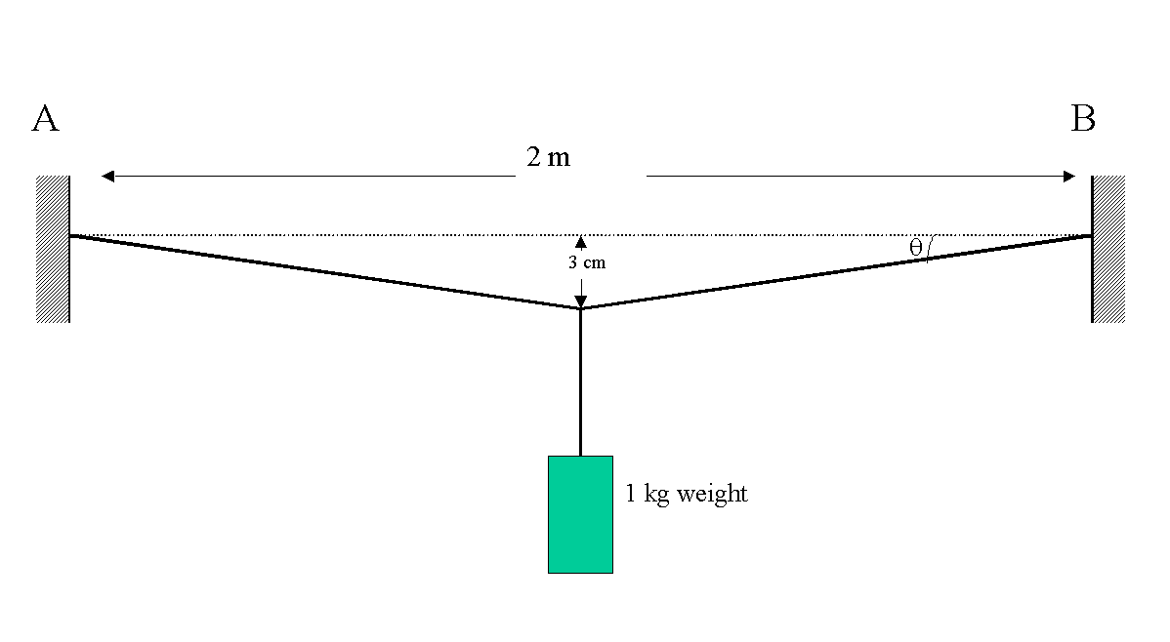

A wire of 2mm diameter is stretched between two immobile anchor points, A and B, that are 2m apart. The wire is initially straight (totally horizontal) and has a negligible tensile stress. Subsequently, when a 1-kg weight is suspended from the midpoint, the vertical movement of the midpoint (at mechanical equilibrium) is 3cm.
Note: At equilibrium the vertical force exerted by the suspended weight is balanced by the vertical components of tension in the two arms of the wire.

(a) What is the total length of the wire after the weight has been suspended? (2 point)
Length of the wire after suspending the weight = 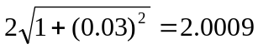m

(b) What is the axial strain in the wire? (2 point)
Strain ε_{y} = (2.0009 - 2.0)/2 = 0.00045

(c) What is the value of tensile stress in the wire? (5 pts)
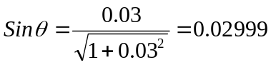 Therfore, θ = 1.72º
Force balance in the vertical direction gives
2T*Sinθ = 1.0 x 9.81 ➔ T = 9.81/(2 * 0.02999) = 163.6 N
Original cross-sectional area = πD²/4 = 3.1416 x(0.002)²/4 = 3.14 x 10⁻⁶ m²
Tensile stress in the wire = F/A = 163.6/3.14 x10⁻⁶ = 52. MPa

- Calculate the Young's modulus of the wire material. (3 pts)
Stress, σ_{y} = 52 MPa
Strain ε_{y} = (1.00045 -1.0)/1 = 0.00045
Young's modulus, E = 52 MPa/0.00045 = 115.6 GPa

(e) Given that the Poisson ratio of the wire material is 0.33, calculate the diameter of the wire after the weight has been suspended. (4 pts)
Total axial stress in the wire = 52 MPa
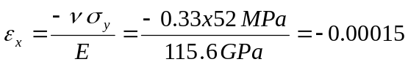Diameter of the wire under axial stress of 52 MPa = 2 mm x (1 - 0.00015) = 1.9997 mm

Question #6: (15 points)
This is a 15-part multiple-choice question. (15 points)
(1) For a given non-Newtonian fluid, the apparent viscosity is: (1 pt)
- A constant property of the fluid involved,
- A function of pressure and temperature only,
- Always decreases with increasing shear rate,
- None of the above.

(2) Concerning the compressibility factor (Z) of a real-gas mixture of specified composition at given values of temperature and pressure, which of the following statements is not true? (1 pt)
- The compressibility of the mixture can be estimated from those of the individual components.
- The mixture compressibility can be estimated from pseudo critical properties of the mixture, with help of a compressibility chart.
- An equation of state with appropriate mixing rules can be used to calculate the mixture compressibility.
- The compressibility of a real-gas mixture is always smaller than that of an ideal gas.

(3) For the critical point of pure substance, which of the following statements is incorrect? (1 pt)
- Heat of vaporisation is zero at the critical point.
- At the critical point, vapour and liquid have the same molar volume.
- The critical point is a property of the substance that varies with P and T.
- The number of degrees of freedom is zero at the critical point.

(4) An unknown Newtonian fluid is flowing through a pipe of unspecified internal diameter. The only information available is the Reynolds number. Which of the following can you determine from the known value of Reynolds number? (1 pt)
- An estimate of the average fluid velocity,
- An estimate of the viscosity of the fluid,
- An estimate of the Pressure drop per unit length of the pipe,
- Whether or not the flow is turbulent.

(5) For turbulent flow in pipes, which one of the following statements is incorrect? (1 pt)
- The fluid velocity at any given location is subject to fluctuations,
- Compared to laminar flow, the energy dissipation is lower in turbulent flow,
- Compared to laminar flow, the velocity profile is flatter in turbulent flow,
- Wall roughness is an important consideration in turbulent flow.

(6) A pipeline designer is interested in reducing the daily energy consumption for transporting a specified volume of fluid through a pipeline. Which of the following suggested options, the designer should reject without any further considerations? (1 pt)
- Increase the pipeline diameter.
- Switch from commercial steel pipe to smooth walled pipe.
- Double the flow-rate in the original pipeline and run it only 12 hours per day.
- Bury the pipeline deeper underground, so that it stays at higher temperature.

(7) A fluid contained in a pipe does not flow at all until the applied pressure gradient is increased to a threshold value. Which of the following categories would you place this fluid in? (1 pt).
- Rheopectic fluid
- Dilatant fluid
- Bingham plastic fluid
- Pseudo-plastic fluid

(8) A mixture contains three liquid components, A, B and C. C is miscible with both A and B, but A and B are totally immiscible with each other. Assuming there is no vapour present, what is the number of phases in such a system? (1 pt)

- 1
- 2
- 3
- 4

(9) The liquid mixture described above is kept at a fixed temperature. What is the number of remaining degrees of freedom for this system? (1 pt)

1 ☒2 3 4

(10) Which of the following statements is true for a mixture of ideal gases? (1 pt)
- Volume percent of component i is always less than mass percent of component i.
- Mole percent of component i is always less than mass percent of component i.
- Volume percent of component i is equal to mole percent of component i.
- Volume percent of component i is equal to mass percent of component i.

(11) Referring to the Lennard-Jones potential function, which of the following is correct? (1 pt)
- At the equilibrium distance r_{o}, intermolecular force (F) is zero.
- At the equilibrium distance r_{o}, intermolecular force (F) is minimum.
- At the equilibrium distance r_{o}, potential (φ) is zero.
- At the equilibrium distance r_{o}, potential (φ) is infinite.

(12) According to the kinetic theory of gases, which of the following relationships between the kinetic energy of an average molecule and the absolute temperature (T) is correct? (1 pt)
- Kinetic energy is proportional to 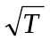
- Kinetic energy is proportional to 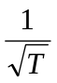
- Kinetic energy is proportional to T
- Kinetic energy does not change with T.

(13) According to the kinetic theory of gases which of the following statements is incorrect? (1 pt)
- Pressure of the gas is an outcome of the collisions of gas molecules with the walls of the container.
- The mean free path of molecules increases with increasing pressure.
- The average velocity of molecules does not depend on pressure.
- The average velocity is a function of the absolute temperature.

(14) Which of the following statements about potential flow is incorrect? (1 pt)
- Potential flow is an idealisation.
- The fluid is considered inviscid.
- Bernoulli's equation is a statement of energy conservation.
- A part of the mechanical energy is converted to heat in potential flow.

(15) One mole of an ideal gas is confined in a 10-L container at 100 ºC. The gas is compressed to a volume of 1L keeping the temperature constant. How does this compression affect the viscosity of the gas? (1 pt)
- Viscosity remains unchanged.
- Viscosity increases 10 folds.
- Viscosity decreases 10 folds.
- Viscosity increases more than 10 folds.

****************************
J.A.
B.M.

ID No:________________________

